Applications Note 3.0
Eagle PCB Technical Applications Note
R.L Pauly Electronic Design
R. L. Pauly
Creating Parts in Eagle
Before I enter into details of how to create parts with EAGLE, let me begin with explaining an overall idea of it. When creating components with EAGLE, it consist of 3 steps. If you are not including a schematic, only follow the steps in defining a package.
The 3 steps we are Package, Symbol and Device. The whole idea is to initially create your package or the physical footprint of your component, then create a schematic symbol representation of it, then create a Device, which is the union of the symbol and the package. This may sound a little confusing at the time, but it will make a lot of sense in a little.
Currently EAGLE consist of approximately 150 libraries. There will be occasions that the entire component you need is not included in our library but maybe one of its components is. For example we may have the Package or a Symbol for a particular IC. EAGLE has the ability of Cutting and Pasting Symbols and Packages between libraries. Devices may not be transferred between libraries.
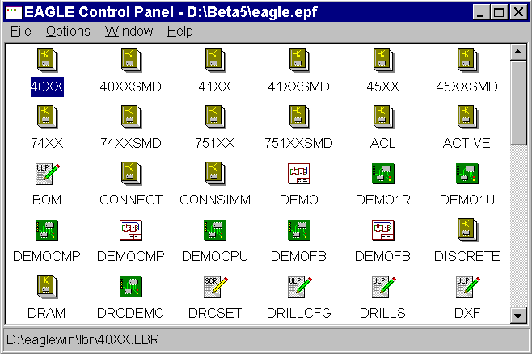

EAGLE Control Panel

Cutting and Pasting between libraries

First begin with teaching you how to open a library for editing purpose. From the control panel click on FILE/OPEN/LIBRARY. This will open a dialog box showing a path and all of the libraries in that particular path. By default EAGLE will install all of the libraries in the directory C:\PROGRAM FILES\EAGLE\LBR.

Select the library that contains the Package or Symbol you want transferred to your own library.

You will notice a blank screen with certain tool bars active. From here you may select if you want to edit a symbol or a package. For this exercise we will select to edit a package.

Click on the Edit a Package Icon. A dialog box will appear with all the Packages in the present library. Select the package you want to transfer and click OK. You will now be located in the package editor section with the package located in the center of your screen. To select the current package use the group icon. Take your mouse cursor and click with your left mouse key and drag a rectangle to cover your entire package. When you release your mouse cursor you will notice all the items in your package will highlight. This means the package has been selected. Now click on the cut icon, place your mouse cursor anywhere in the drawing area and press your right mouse button. This will place this current package in the EAGLE clipboard. Now you may close the library and open another library or create your own. When you close the library you will located at the EAGLE Control panel. From here you may click on FILE/OPEN/Library or click on FILE/NEW/Library. After you have opened another library click on the edit package icon when the dialog box appears you will notice a field on the bottom that says new, type in the

name of the new package you wish to create. You could use the same name of the package from the previous library. Click on OK, EAGLE will prompt you if you wish to create a new package, select OK. This will bring you to a editor screen with a grid. Click on the paste icon and you will notice as you move your mouse cursor that the package is now attached to it. Place the package anywhere on the screen. We prefer to place the component with the origin of the page in the center of the package. This makes it easier to select on the board layout level.

Follow the same steps for a schematic symbol.

Summary
- Open the library that contains the package or symbol you want to transfer.
- Edit the package or symbol you wish to select.
- Create a group around the item you selected.
- Click on the cut icon and place your mouse cursor anywhere in the drawing area and click with your right mouse key.
- Open your new library.
- Create a new package or symbol by selecting the appropriate edit icon.
- Give you component a name on the bottom of the dialog box.
- Click on the paste command.
Edit a package Group Paste
Edit a symbol Cut

Package Definition
As I mentioned before a Package is the physical footprint of your component. It is very important you gather the proper data for the package in regards of pads spacing, diameter of pad and the size of the drill for the pad as well. After gathering, all of this information lets proceed to create the package. From the control panel click on FILE/NEW/Library if you are creating a new library or click on FILE/OPEN/Library to add to an existing library.

After opening the library, you will be at the initial component library editor screen. Click on the EDIT PACKAGE icon to create a package. When the

dialog box appears towards the bottom you will notice a field with the word NEW to the right of it. Type in the name of the package you wish to create in the empty field, Click OK. EAGLE will prompt you to create a new package, simply acknowledge by pressing the OK button.

At this time you will be located at a blank screen with a grid turned on. The default grid setting are .05 inches. Before you proceed to drop your pads set the grid to match a factor of your pad spacing.
For example, if my pad spacing is .05 inches I will set my grid to .025 that way I know that I place a component at every other grid intersection.

Now to set the pad size. If you are going to work with through hole pads you should first set the pad diameter and the drill size. Click on the change icon and select

the diameter option. Now select the appropriate diameter. Click on the change icon again and this time select the drill option and select the proper drill diameter. Last, select change again and select the option shape and select the appropriate pad shape you wish to use. Now proceed to use the pad icon to place pads on

your package. When placing your pads they will automatically get numbered for you. If you want your pads to be numbered differently simply type the number in between single quotes and EAGLE will continue this sequence.

For example, the first pad that gets placed will be numbered P$1 the second will be P$2 and so on. To change this sequence type the number in single quotes ‘1’. Now the first pad will be 1 and the second one will be 2 and so on. You can also use the name icon to name your pads.

After placing your pads you may want to create a silk screen for your component. The silk screen is done by drawing a wire around your component on the Tplace layer. Click on the change icon and select the option layer and select the Tplace layer. Now select the wire icon and proceed to draw your silkscreen. You

may also want to use other drawing shapes for your silk screen such as Arc, Circle, Rectangle or circle.

Now that you are done with the component outline lets proceed to place fields for the name and the value of the component. Click on the change icon and select the option layer and select the Tname layer. Press the text icon and in the dialog

box type >NAME and click OK. Place the square box that appears on you mouse cursor wherever you want the name of the component to appear.
You place the text by pressing the left mouse cursor.
T o place the value, click on the change icon and select the option layer and click on the Tvalue layer. Press the text icon and type >VALUE and place this text box wherever you want the value text to appear.

***note: As you can notice the silkscreen actually consist of 3 layers: Tplace, Tname and Tvalue. The reason behind this is that it gives the user the option of turning on or off certain layers for viewing or printing purposes.

Your package is finished. If you don’t have the EAGLE schematic editor you will not be able to proceed with the next steps.

Summary
- From the control panel: FILE/NEW/Library or FILE/OPEN/Library and select an existing library.
- Click on the Edit package icon and in the NEW field give your package a name.
- When in the package editor mode, set the following parameter using the change icon:
- Grid
- Pad Size
- Pad Diameter
- Pad numbering.
- Use the PAD icon to drop pads for your package.
- Draw your component outline on the Tplace layer. Place text field for your name and value. The >NAME should be located on the Tname layer and >VALUE should be located on the Tvalue layer.

Icons used for package definition:
Edit a Package Change Name Text

Grid Pad Wire

Symbol Definition
At the schematic symbol section is where you will create a schematic representation of your package. When creating a symbol, spacing nor size is not really a concern but, the name of your pins is.
If you are in the library editor mode you should simply click on the Edit Symbol icon. If you are in the control panel click on FILE/OPEN/LIBRARY and select the library you want to edit then click on the Edit Symbol Icon. A dialog box will appear with a list of symbols in the current library. Towards the bottom you will notice a field with the word NEW, in this field type in the name you wish to give your symbol. The symbol doesn’t have to have the same name as the package.

***Note: You may Group, Cut and Paste symbols between libraries as explained in the first sheet.

Use the pin icon to place your pins on the current screen. After placing your pins you may want to name your pins appropriately by using the NAME icon. After clicking on the NAME icon click on the pin and change its name. Notice that the default names are P$1, P$2 and so on. You may change them to meet your component spec sheet.
After naming your pins you may want to assign them the appropriate direction. The direction is used for your schematic Electrical Rule Checker (ERC). This checks for proper electrical connectivity on your schematic. For example if two output pins are on the same net or there are mixed power pins with regular signal pins.
Now is to create the symbol silkscreen. This silkscreen is used to easily identify the component on the schematic. You may use the wire command on the symbol layer or any other shape you may need on this layer. You might want to change grid sizes if necessary, but make sure to put your grid to the default settings before saving the component.
We are on our final step for the symbol. Now its time to provides fields for the Name and the Value of the component. This is very similar to the Package Definition section. Click on the Change Icon and select the option LAYER, select the NAMES layer. Then click on the Text Icon and type the word >NAME and click OK. This text will appear on your mouse cursor in the form of a rectangular box. Place this box where you want the name of the component to appear on the schematic. Click on the left mouse button to place your text. Remember you may rotate your text while attached to your cursor by pressing the right mouse key.
Click on the Change Icon and select the Layer option and select the VALUE layer. Now select the Text Icon and type >VALUE, place this text wherever you want the value of the component to appear.

Summary
- Open the library that contains the symbol you wish to edit or the library where you want to create a new symbol.
- Click on the Edit Symbol Icon. On the dialog box that appears, select the symbol your are going to edit or in the NEW field provide a name for a new symbol.
- Place pins. (Pin Icon)
- Name Pins. (Name Icon)
- Give you pins the proper direction. (Change Icon / Layer)
- Create a symbol silkscreen on the symbol layer. (Change Icon / Layer/Symbol)
- Create the >NAME field on the name and the >VALUE on the value layer.

Icons to be used:
Edit a Symbol Change Wire

Pin Text

Device Definition
The Device is the final level when creating components with EAGLE. At this stage you will create a relation between the package and the symbol. When editing the device you will not do any drawing such as wires or anything of the sort.
If you are in the library editor mode already click on the Edit Device Icon and select the device to edit or the new device you wish to create. If you are at the EAGLE control panel click on FILE/OPEN/LIBRARY and select the library to edit.
After entering the device editing mode you will notice a blank screen. Click on the Add Icon to add a the schematic symbol on the device. Place as many symbols that are contained in this package. After placing all of the symbols needed click on the Stop sign. Now the you have place the symbol you wish to use we need to let EAGLE know what package is going to use with that symbol. Click on the Package Icon. Now you will be able the see a list of packages in this library. Select the appropriate package and click OK. You will not notice any change.
Click on connect Icon to begin making or assigning the Pin to Pad relation. You will notice a pop up box with 3 columns.
The first column has the names of your pins, the column in the middle has the pad numbers and the third column will be blank. In bottom of the dialog will appear a large button that says connect.
To create a relation between a pin and a pad simply highlight the pin on the first column then highlight the pad you wish to assign it to in the middle column and press the connect button. Now that pin/pad assignment will appear in the third column.
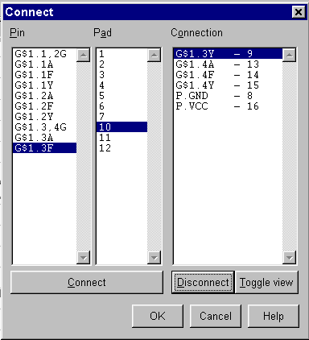
If you notice in the first column where the name of the pin is located you will see a G$1 parameter. This refers to the gate which is being refer to. If you had a multi-gate system you would notice a G$2, G$3 and so on but the pin names would keep repeating it self.

After you have completed your pin / pad connections your device is now created. If you find that you may have made a mistake in your connections, you can select Disconnect to break the connection and start over again. When you are done with you connections click on the save tool button or select file and save to store the device in your library. This device is now available to use in your design. I would suggest creating a libraryname.log file to add additional entries or corrections to you library. A sample *.log template was supplied with this applications note.

In Conclusion:
This applications note has been created in order to help fellow Eagle users with their design efforts. Although great care was taken to make this document as accurate as possible, it should be verified. R.L. Pauly Electronic Design is not responsible for extra design or manuafacturing costs as a result of this document. This document has been created free of charge for Eagle users. Any comment concerning this document is greatly appreciated and can be sent to:
Bob Pauly
R.L. Pauly Electronic Design
Emial: rpauly@pdq.net

If you would like to learn more about services for EaglePCB offered by R.L. Pauly Electronic Design please use the Email address above or consult the DOWNLOAD section of the CadSoft website. You can also send the form below for information.

Cut here

Please send more more information about EaglePCB services and products

Name ____________________ Phone _________________
Address: _________________________ Email:__________________
__________________________
send to: R.L. Pauly Electronic Design
1206 Eagle Lakes, Friendswood, TX 77546

